Submitted by-

Name- Ishan Rawat

SAP ID- 500087524

Roll no- R2142201888

Application Containerization and Orchestration Lab

# Experiment –2

**Aim:** Working with Docker (Basic Commands)

Step 1: Search a Redis image on DockerHub

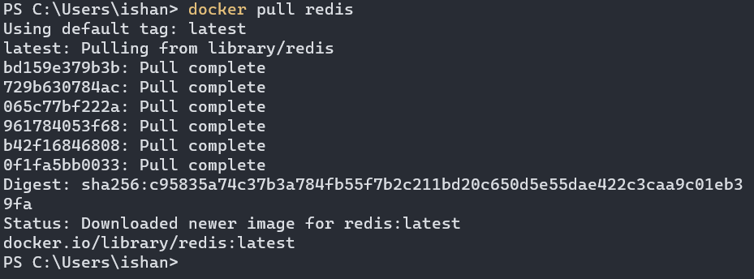

Step 2: Run Docker Container of Redis Image in background

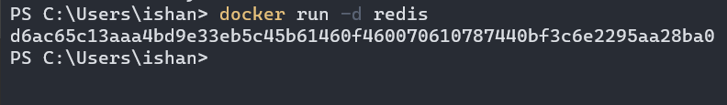

Step 3: Run Docker PS and Docker PS –a

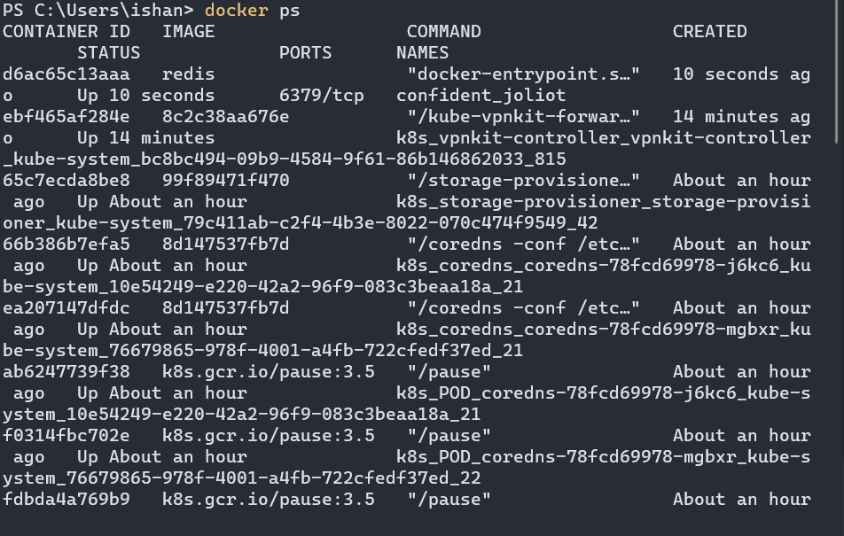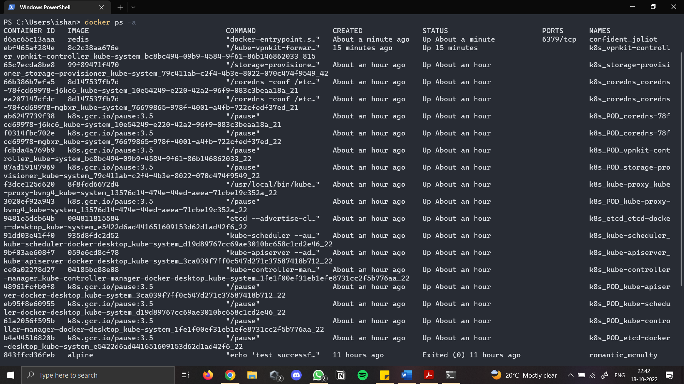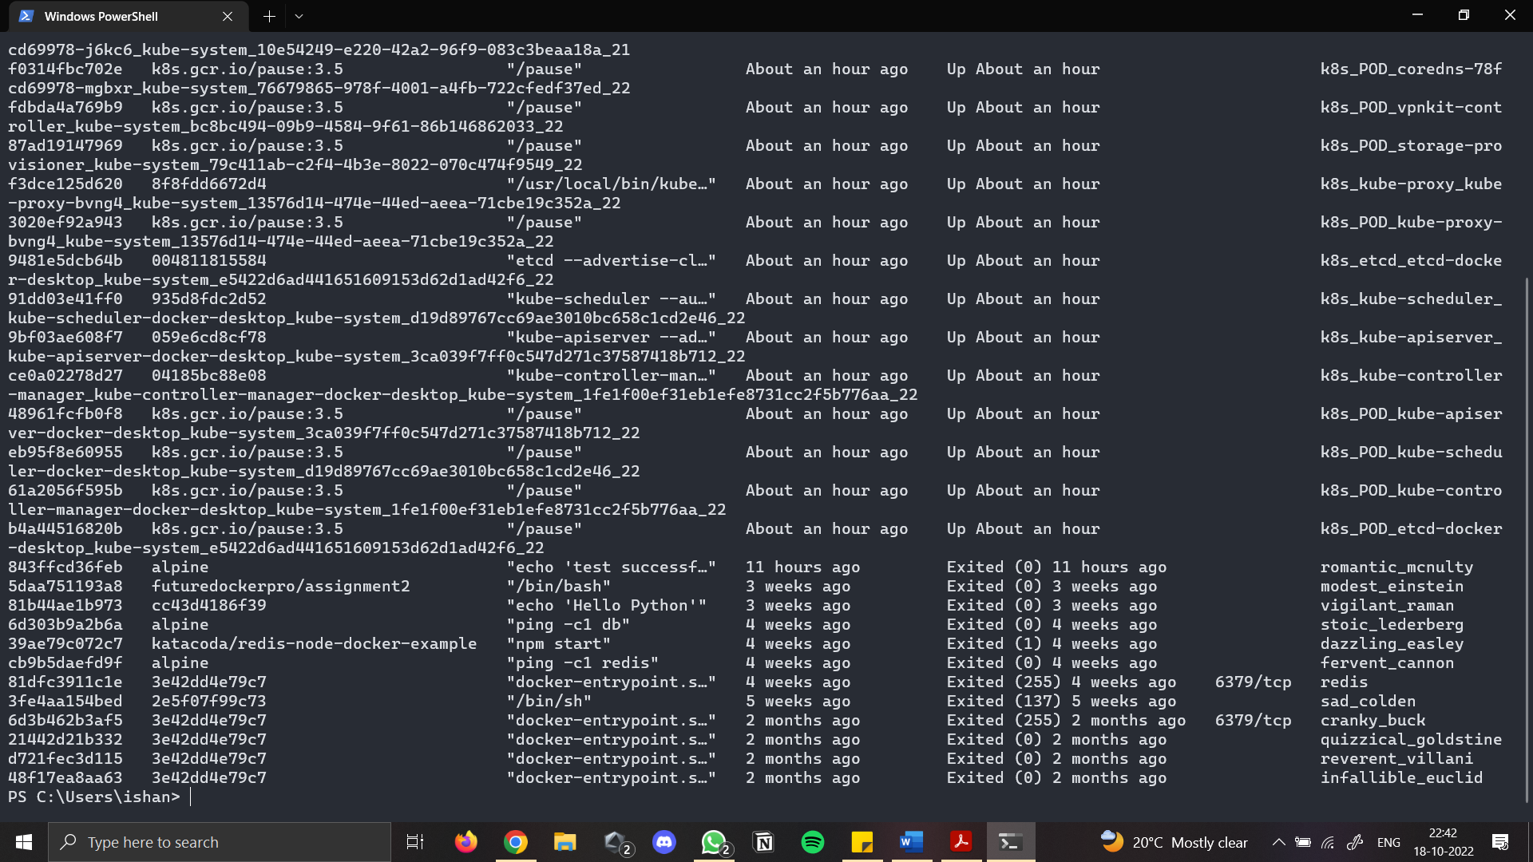

Step 4: Run Docker Container and take its console

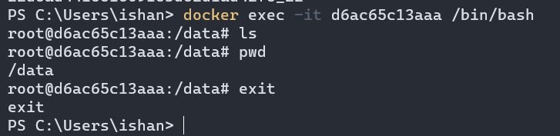

Step 5: Create a Docker Volume and connect it

